# Computer Specifications:

* CPU
  + Brand: Intel
  + Model: Quad-Core Intel Core i7
  + Cores: 4
  + Base Clock: 2.90nGHz
* 16 GB 2133 MHz
* 256 GB SSD
  + Max Sequential Read: 3.1GBps
  + Max Sequential Write: 2.1GBps
  + Max Random Read 4k: 110,00 IOPS
  + Max Random Write 4k: 315,00 IOPS

**Float benchmark:**



**Hard Drive 1 Benchmark:**



**Hard Drive 2 Benchmark:**

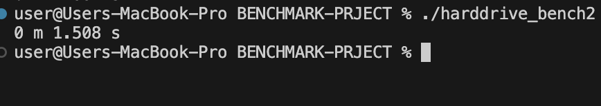

**Integer Benchmark:**



**Memory Benchmark:**



|  |  |  |  |  |  |
| --- | --- | --- | --- | --- | --- |
| Float | Harddrive1 | Harddrive2 | Memory | Integer | Mean |
| 10m 57.926s | 1.881s | 1.508s | 23.434s | 10m 23.791s | 30.702s |

**I COMMITED MY CODE WHILE CODING BUT I MADE A MISTAKE WITH HOW I PUSHED IT, HERE IS A SCREENSHOT OF THE FAILED COMMITS:**

